**Analysis Explanation**

**Script: general.py**

**Python Script Explanation:**

The Python code script was designed to analyze the user behavior in an e-commerce context by tracking the conversion rates at different stages of the user journey, from visiting the homepage to completing a payment confirmation and identifying drop-off points. It utilizes the pandas library for data manipulation and matplotlib and plotly for visualization.

**Steps Details:**

1. **Import Libraries:** The code begins by importing the necessary libraries: pandas for data handling and matplotlib.pyplot for plotting.
2. **Load the Data:** Data from five CSV files is loaded into separate DataFrames. Each file corresponds to a different stage of the user journey.
3. **Count Unique Users:** The code calculates the number of unique users at each stage using the nunique() function, which counts distinct user IDs.
4. **Calculate Conversion Rates:** Conversion rates are calculated for each stage by dividing the number of users at the current stage by the number of users at the previous stage, multiplied by 100 to get a percentage.
5. **Identify Drop-off Points:** The code calculates the number of users who drop off at each transition between stages.
6. **Print Results:** The results, including total visits, conversion rates, and drop-off numbers, are printed to the console.
7. **Visualize the Conversion Funnel:**

* **Option 1: Bar Chart:** A bar chart is created to visualize the number of users at each stage of the funnel.
* **Option 2: Funnel Chart:** A funnel chart is created using plotly, providing a more visually appealing representation of the conversion process.

**Results obtained from the Python Script:**

**-Total Home Visits:** 90400

**-Total Search Visits:** 45200

**-Total Payment Visits:** 6030

**-Total Confirmations:** 452

**-Search Conversion Rate:** 50.00%

**-Payment Conversion Rate:** 13.34%

**-Confirmation Conversion Rate:** 7.50%

**-Drop-off from Home to Search:** 45200

**-Drop-off from Search to Payment:** 39170

**-Drop-off from Payment to Confirmation:** 5578

**Visualize the conversion funnel - Option 1:**

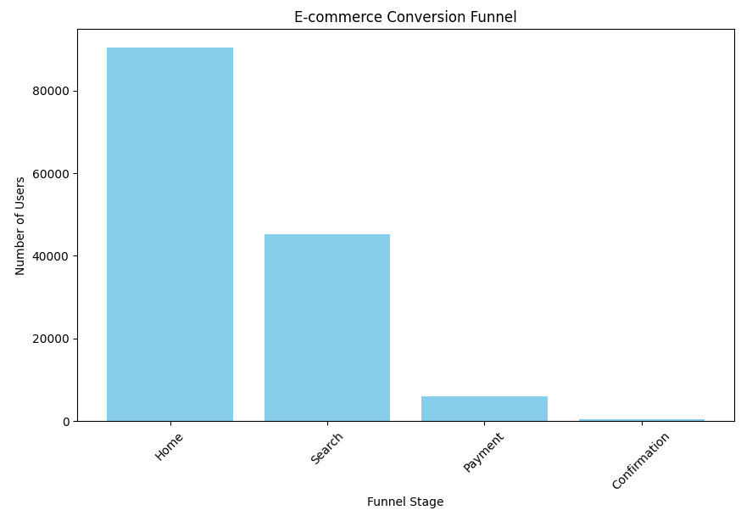

**Visualize the conversion funnel - Option 2:**

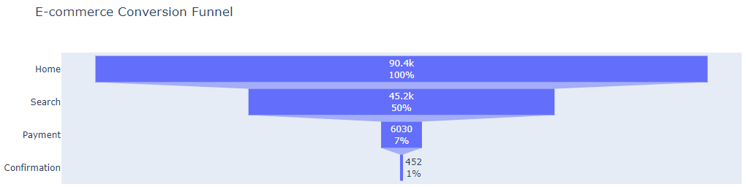

**Conclusions and Insights:**

Based on the results obtained about the conversion funnel metrics, conversion rates and drop off points, we can draw several conclusions regarding the performance of the sales process and identify potential areas for improvement:

1. **Conversion Rates**:
   * The **search conversion rate** of **50%** is decent, but the subsequent payment conversion rate drops significantly to **13.34%**. This indicates a potential issue with the checkout process or the perceived value of the products.
   * The **confirmation conversion rate** of **7.50%** is alarmingly low, suggesting that there may be issues with payment processing, user trust, or the overall user experience during the final steps of the purchase.
2. **High Drop-off Rates**:
   * **From Home to Search**: There is a significant drop-off of **50%** (45,200 out of 90,400) from home visits to search visits. This indicates that while many users are visiting the home page, a large portion is not engaging further by searching for products or services.
   * **From Search to Payment**: The drop-off from search visits to payment visits is also substantial, with 39,170 users not proceeding to make a payment after searching. Only **13.34%** of searchers proceed to make a payment. %. This indicates potential issues in the search results or product offerings that may not meet user expectations, leading to a loss of interest or confidence in making a purchase.
   * **From Payment to Confirmation**: The conversion from payment to confirmation is low at **7.50%**, indicating that even those who initiate a payment are not completing the transaction.

**Recommendations for Improvement**

1. **Enhance User Engagement on the Home Page**:
   * **Improve Navigation**: Ensure that users can easily find what they are looking for. Consider implementing clearer calls-to-action (CTAs) and highlighting popular products or categories.
   * **A/B Testing**: Experiment with different layouts, content, and promotional banners on the home page to see what drives more users to search.
2. **Optimize the Search Experience**:
   * **Refine Search Functionality**: Ensure that the search feature is robust, providing relevant results quickly. Consider adding filters and sorting options to help users find products that meet their needs.
   * **Personalization**: Use data analytics to personalize search results based on user behavior, preferences, and demographics, which can increase engagement and conversion rates.
3. **Streamline the Checkout Process**:
   * **Reduce Friction**: Analyze the checkout process to identify any barriers that may be causing users to abandon their carts. Simplifying forms, offering guest checkout options, and minimizing the number of steps can help.
   * **Trust Signals**: Incorporate trust signals such as security badges, customer reviews, and clear return policies to reassure users during the payment process.
4. **Follow Up with Abandoned Carts**:
   * Implement an email marketing strategy to follow up with users who abandon their carts. Remind them of the items left behind and consider offering incentives such as discounts or free shipping to encourage completion of the purchase.
5. **Analyze User Behavior**:
   * Utilize analytics tools to track user behavior throughout the funnel. Understanding where users drop off can provide insights into specific pain points that need addressing.
6. **Target New Users**:
   * Develop targeted marketing campaigns aimed at new users, highlighting the benefits of your products and any introductory offers. This can help increase the volume of sales from new customers.

The current conversion funnel indicates significant drop-offs at multiple stages, particularly from home visits to search and from payment to confirmation. By implementing the recommended strategies, the company can enhance user engagement, streamline the purchasing process, and ultimately improve conversion rates.